- What is the difference between a sequence and a series? Provide examples.
- What is meant by a p-series? For what p-values do p-series converge/diverge?
- What is meant by absolute and conditional convergence? Use an example in your explanation.

- A series is the sum of some set of terms of a sequence. A sequence is a set of ordered numbers. This being said a series is a set of sequences. For example 1,2,3,4 is a sequence and (n) = n +1 is a series which defines this sequence.
- A p-series is an infinite series which can reduce to 1/n^p, if we can reduce an infinite series to this form we can determine if it converges or diverges by the value of P. If P > 1 then the series converges if P <= 1 then the series diverges. There are other properties we can assume when we identify an infinite series as a p-series but generally this is the one which is most helpful.
- If we take our infinite series and determine if it converges then we take the infinite series and make it value absolute and it still converges we know the series absolutely converges. Absolute convergence gives us properties we can assume about the infinite series.
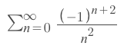 and 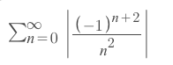both converges thus Absolute convergences.

